RMSST 9th Grade Literature and Composition Summer Reading Assignment
Welcome to 9th grade literature at Rockdale Magnet School for Science and Technology. You will complete THREE assignments for Summer Reading. This document can also be found on the Magnet website.
Refer to this video (http://tinyurl.com/magnetsummerreading) to access a welcome message and introduction to the summer reading assignments.
Complete ALL of the following:
- Read The Happy Student: 5 Steps to Academic Fulfillment and Success, by Daniel Wong. Complete a double-entry journal for this book (p. 2-3). You will be using The Happy Student throughout the semester in Research 1, High School 101, and Magnet 9th Grade Literature and Composition, and there will also be an in-class discussion over the book within the first weeks of school.

- Select ONE book from the school summer reading list (p. 4). Complete Personal Reading Reflection and Pre-writing page(s) (p. 5-6).

- Select an article set from the APES Connection page (p. 7). Read all materials and complete FOUR article/video review forms (p. 8).

All assignments will be turned in SEPARATELY. Please do not staple everything together/create one big packet, as these are each graded separately and at different times.
Summer Reading assignments will be due:
Monday: August 10 (A day)*
Tuesday: August 11 (B day)*
*You will know at Open House if you have my class on an A or a B day.
Please note: If you will need to print your work at school, PLEASE bring it on a flash drive (or upload to One Drive/Google Drive) BEFORE the due date. You will be allowed to print from one of my computers in class. Emailed work will not be accepted.
If you have any questions about the summer reading assignment, please email Mrs. Wisnewski at kwisnewski@rockdale.k12.ga.us.

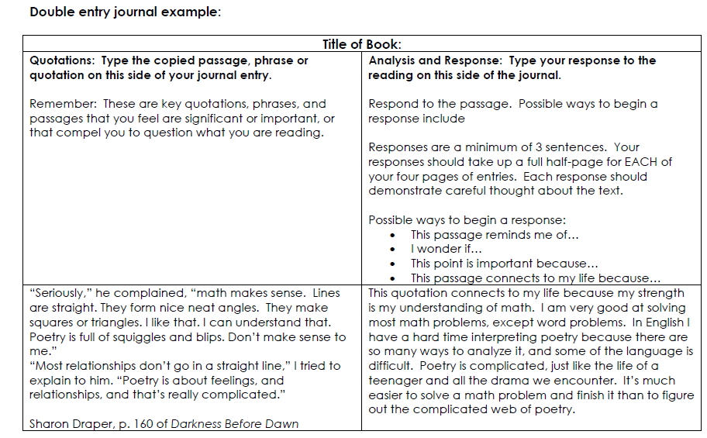
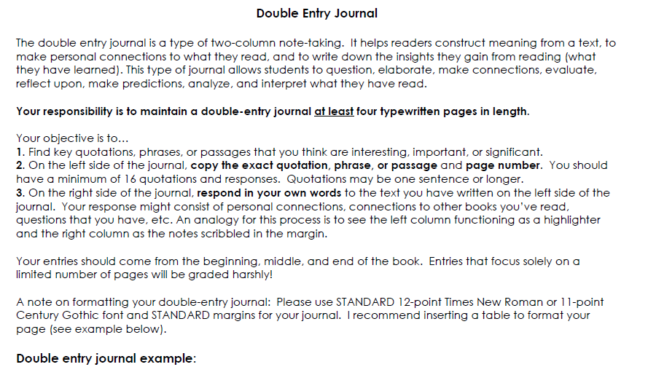
Reading Assignment #1: The Happy Student/ Double-entry Journal

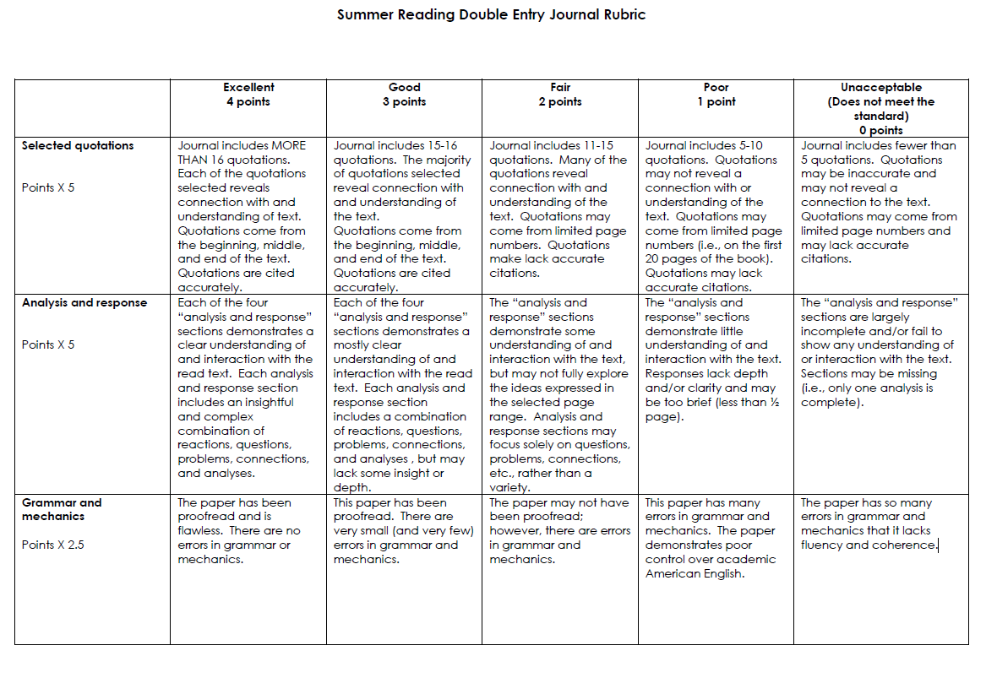

Title | Author | Lexile | Genre
Outcasts United^ | Warren St. John | 980L | Nonfiction: Sports
Into Thin Air | John Krakauer | 1320L | Nonfiction: Memoir
Stamped: Racism, Anti-racism, and You | Jason Reynolds | 1000L | Nonfiction: History w/ modern twist
Navigating Early | Clare Vanderpool | 790L | Fiction: Historical/Disability
A Good Girl’s Guide to Murder* | Holly Jackson | 700L | Fiction:  Contemporary/Thriller
Let Me Hear a Rhyme* | Tiffany D. Jackson | 610L | Fiction:  Contemporary: Social Issues
Catch-22 | Joseph Heller | 1140L | Fiction: Historical/War
The Curious Incident of the Dog in the Night-time | Mark Haddon | 1180L | Fiction: Contemporary/Disability
This One Summer | Mariko Tamaki, Jillian Tamaki | --- | Fiction  Contemporary: Graphic Novel
Reading Assignment #2: School Choice Book/ Reading Inventory
** Some of these books might contain content with which you are uncomfortable. Check commonsensemedia.org or email me if you have questions about content of a particular book.**

^be sure you select the correct edition, as this book has an abridged edition. Yours should be 240+ pages.
*suggested for anyone interested in Book Club/Reading Bowl
**Please note: completing 10 Achieve3000 articles/activities is NOT an acceptable substitute for rising RMSST students.**
Reading Inventory/Response Form
Answers may be typed or handwritten and can be on a
separate sheet of paper if needed.

Name:
Title of Book: Author:

As you read, keep a running list of unfamiliar words. Use context clues to make a guess as to their meaning, and then use a dictionary (or dictionary.com, or whatever else you have at your disposal) to look up an exact definition. You should have at least FIVE words listed. You may write them on the back of this, type them, or write them on a separate sheet of paper.

Firstly, hello! Welcome to 9th Grade Literature. In a few sentences, please tell me what kinds of books you tend to read, and/or how you feel about reading in general.

What problems do you sometimes have while reading (if any), and what do you do (or what can you do) to solve these problems (Yes, getting bored and/or falling asleep IS an acceptable answer here)?

What is ONE book that has had a strong impact on you, and why is this book important to you?

What makes a “good book” to you?

What makes a “bad book” (don’t say “boring,” unless you plan to go into more detail to support your answer)?

Now, think about this book. The one you just read. Was it like other books you’ve read? How so?

How was it different from other books you’ve read?

What about this book will stay with you months from now?

Did it make you consider anything about life and/or people/society? Were you able to relate to it? How so?

Select THREE quotations from this book that you think are important. Why do you think these quotations stood out to you? Did they make you think deeply about anything?

Pre-write
Your responses to the following questions will assist you in writing your Summer Reading essay a few weeks into the semester. You do NOT need to write the essay now.

Who is your main character (if your book has several stories, select one character to focus on)?

What do they want for most of the book?

What gets in the way of your character achieving this goal?

What could happen if your character does not achieve this goal?

How is the conflict resolved? Is the goal achieved, partially achieved, or changed?

What does your character learn, and/or how has your character changed from the beginning?

Reading Assignment #3: APES Connection

You will select ONE of the two topics described below and complete ALL assignments associated with your topic. Articles/videos can be found online.

Topic One: “Feeding 9 Billion”

Link: https://www.nationalgeographic.com/foodfeatures/feeding-9-billion/

Read ALL Articles:
- “Where Will we Find Enough Food for 9 Billion?”
- “Can the Blue Revolution Solve the World’s Food Puzzle?”
- “Can Africa’s Fertile Farmland Feed the World?”
- “Why are People Malnourished in the Richest Country on Earth?”
- “Could Eating Like our Ancestors Make us Healthier?”
- “Science Prevented the Last Food Crisis. Can it Save Us Again?”
- “Is America’s Appetite for Meat Bad for the Planet?”
- “What is it about Eating that Brings us Closer?”

*Note: You will see the above titles written in a colorful circle. Scroll down to read the article. Click the arrow on the right to read the next article. Click the arrow on the left to read the previous article.

Select FOUR articles, and complete the “Article/Video Review form” for EACH article.

Topic Two: “Big Cats Initiative”

Link: https://www.nationalgeographic.org/projects/big-cats-initiative/education/

Read ALL Case Studies:
- “The Greater Southern Bypass”
- “Big Cats in the Maasai Steppe”
- “Big Cats in the Ruaha Landscape”

Read ALL Resources for Grades 9-12
(Scroll down to find)
- “Introduction to Captive Breeding”
- “Captive Breeding and Species Survival”
- “Captive Breeding Case Studies”

Watch the following videos:
(on bottom of page – You will need to click the scroll arrows on the right side. Arrows appear when you hover over the video)
- “Lions vs Hyenas: Competing Interests”
- “Threats to Big Cats: Poachers”
- “Protecting People”

Select THREE articles and ONE video, and complete the “Article/Video Review form” for EACH article/video selected

Article/Video Review Form
Topic:
Article/Video title:

In THREE sentences, state the overall topic of this article/video | Sentence 1
 | Sentence 2
 | Sentence 3
Describe TWO new concepts/ideas that you learned from this article | Concept 1 – Describe using 3-4 sentences
 | Concept 2 – Describe using 3-4 sentences
Identify and define THREE unfamiliar words from this article | Term 1 | Definition
 | Term 2 | Definition
 | Term 3 | Definition

Article/Video Review Form
Topic:
Article/Video title:

In THREE sentences, state the overall topic of this article/video | Sentence 1
 | Sentence 2
 | Sentence 3
Describe TWO new concepts/ideas that you learned from this article | Concept 1 – Describe using 3-4 sentences
 | Concept 2 – Describe using 3-4 sentences
Identify and define THREE unfamiliar words from this article | Term 1 | Definition
 | Term 2 | Definition
 | Term 3 | Definition

Article/Video Review Form
Topic:
Article/Video title:

In THREE sentences, state the overall topic of this article/video | Sentence 1
 | Sentence 2
 | Sentence 3
Describe TWO new concepts/ideas that you learned from this article | Concept 1 – Describe using 3-4 sentences
 | Concept 2 – Describe using 3-4 sentences
Identify and define THREE unfamiliar words from this article | Term 1 | Definition
 | Term 2 | Definition
 | Term 3 | Definition

Article/Video Review Form
Topic:
Article/Video title:

In THREE sentences, state the overall topic of this article/video | Sentence 1
 | Sentence 2
 | Sentence 3
Describe TWO new concepts/ideas that you learned from this article | Concept 1 – Describe using 3-4 sentences
 | Concept 2 – Describe using 3-4 sentences
Identify and define THREE unfamiliar words from this article | Term 1 | Definition
 | Term 2 | Definition
 | Term 3 | Definition

